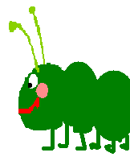 | a Christmas tree | a Christmas tree
 | a Christmas ball | a Christmas ball
 | a bell | a bell
 | Christmas stocking | Christmas stocking
 | Santa Claus | Santa Claus

 | a star | a star
 | a pastry ring | a pastry ring
 | a reindeer | a reindeer
 | a snowman | a snowman
 | a stable | a stable

 | a sledge | a sledge
 | an angel | an angel
 | 

