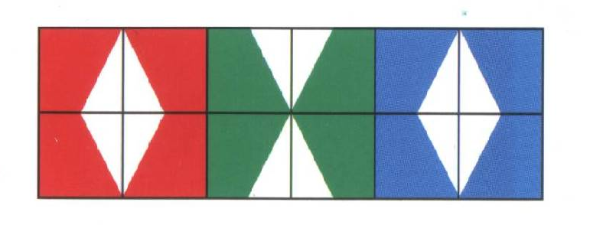

1  80:10= | 2  30:10= | 3  50:10= | 4  120:10= | 5  40:10= | 6  20:10=
7  110:10= | 8  90:10= | 9  60:10= | 10  10:10= | 11  100:10= | 12  70:10=

4 | 10 | 12 | 8 | 7 | 9
5 | 6 | 11 | 1 | 2 | 3

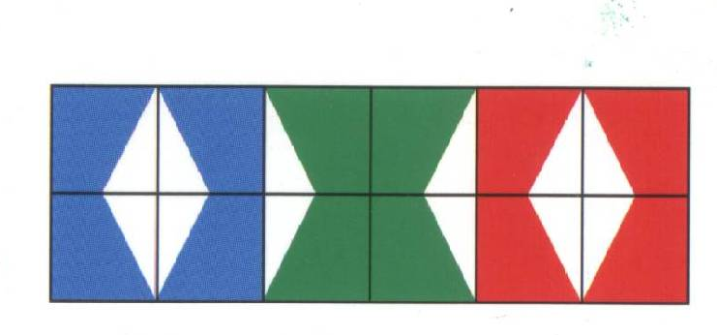

1  54:9= | 2  27:9= | 3  63:9= | 4  18:9= | 5  81:9= | 6  99:9=
7  9:9= | 8  36:9= | 9  72:9= | 10  108:9= | 11  45:9= | 12  90:9=

10 | 4 | 12 | 1 | 9 | 5
11 | 3 | 6 | 2 | 7 | 8

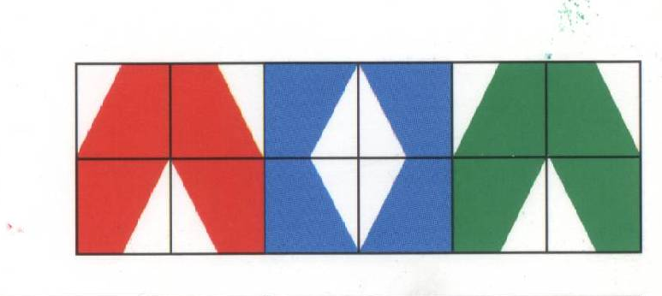
1  20:2= | 2  16:2= | 3  12:2= | 4  2:2= | 5  6:2= | 6  8:2=
7  18:2= | 8  4:2= | 9  14:2= | 10  10:2= | 11  24:2= | 12  22:2=

6 | 7 | 11 | 2 | 1 | 10
12 | 3 | 4 | 8 | 5 | 9

1  25:5= | 2  20:5= | 3  45:5= | 4  35:5= | 5  10:5= | 6  15:5=
7  40:5= | 8  60:5= | 9  55:5= | 10  30:5= | 11  50:5= | 12  5:5=

2 | 10 | 7 | 5 | 1 | 12
9 | 11 | 8 | 6 | 3 | 4

