1  animal | 2  horse | 3  monkey | 4  lion | 5  mouse | 6  cat
7  chicken | 8  dog | 9  tiger | 10  frog | 11  snake | 12  duck
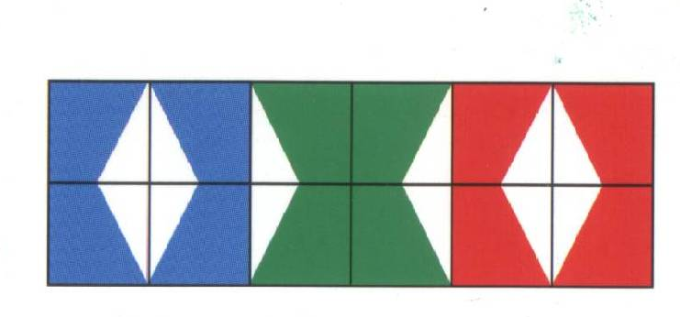
eend | hond | kikker | kip | muis | slang
kat | paard | dier | leeuw | aap | tiger

