1  girl | 2  uncle | 3  woman | 4  father | 5  boy | 6  cousin
7  mother | 8  grandfather | 9  brother | 10  man | 11  aunt | 12  grandmother
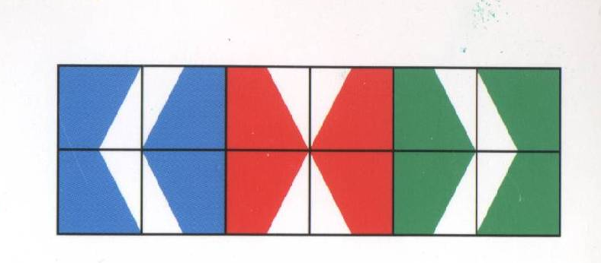
oma | oom | vrouw | broer | vader | man
neef/nicht | opa | jongen | tante | moeder | meisje

