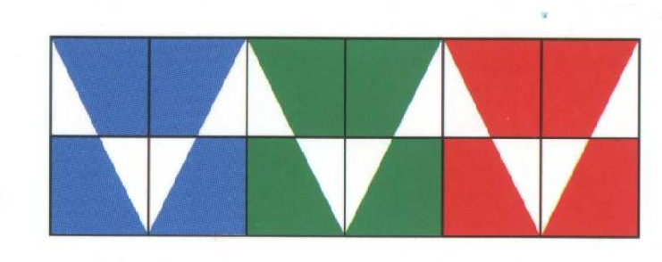
1  zwart | 2  geel | 3  rood | 4  blauw | 5  rose | 6  wit
7  paars | 8  oranje | 9  groen | 10  grijs | 11  bruin | 12  lila

lilac | orange | purple | grey | pink | brown
yellow | white | black | blue | green | red

