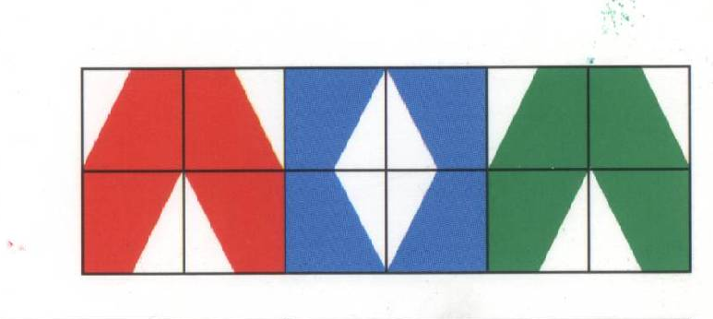
1  4x4= | 2  9x4= | 3  1x4= | 4  12x4= | 5  5x4= | 6  8x4=
7  10x4= | 8  2x4= | 9  11x4= | 10  3x4= | 11  7x4= | 12  6x4=

4 | 44 | 24 | 8 | 48 | 16
28 | 20 | 32 | 36 | 12 | 40
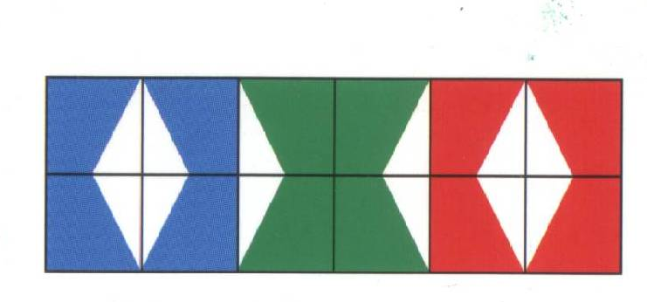
1  12x5= | 2  2x5= | 3  7x5= | 4  9x5= | 5  4x5= | 6  10x5=
7  1x5= | 8  8x5= | 9  6x5= | 10  11x5= | 11  3x5= | 12  5x5=

25 | 40 | 55 | 5 | 20 | 15
50 | 10 | 60 | 45 | 35 | 30
1  4x6= | 2  2x6= | 3  11x6= | 4  8x6= | 5  1x6= | 6  5x6=
7  12x6= | 8  3x6= | 9  10x6= | 10  7x6= | 11  6x6= | 12  9x6=

66 | 60 | 54 | 18 | 48 | 24
36 | 6 | 30 | 12 | 42 | 72

1  10x7= | 2  2x7= | 3  5x7= | 4  11x7= | 5  3x7= | 6  8x7=
7  1x7= | 8  7x7= | 9  12x7= | 10  4x7= | 11  9x7= | 12  6x7=

42 | 49 | 28 | 7 | 21 | 63
56 | 14 | 70 | 77 | 35 | 84

1  4 x 7= | 2  6x6= | 3  9x7= | 4  5x6= | 5  6x7= | 6  9x6=
7  5x7= | 8  8x6= | 9  3x7= | 10  7x7= | 11  5x6= | 12  4x6=

63 | 21 | 24 | 48 | 30 | 28
30 | 42 | 54 | 36 | 49 | 35

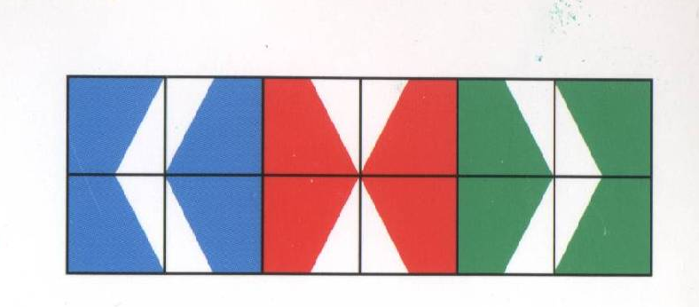
1  5x8= | 2  10x8= | 3  2x8= | 4  12x8= | 5  4x8= | 6  7x8=
7  1x8= | 8  9x8= | 9  3x8= | 10  8x8= | 11  11x8= | 12  6x8=

48 | 80 | 16 | 24 | 96 | 64
56 | 72 | 32 | 88 | 8 | 40

1  5x5= | 2  5x8= | 3  9x8= | 4  7x5= | 5  6x5= | 6  9x5=
7  7x8= | 8  8x8= | 9  4x8= | 10  4x5= | 11  6x8= | 12  3x8=

72 | 32 | 24 | 64 | 35 | 25
48 | 30 | 45 | 40 | 20 | 56

1  2x9= | 2  5x9= | 3  10x9= | 4  8x9= | 5  1x9= | 6  3x9=
7  12x9= | 8  7x9= | 9  4x9= | 10  11x9= | 11  6x9= | 12  9x9=

81 | 45 | 90 | 36 | 72 | 99
27 | 63 | 9 | 54 | 108 | 18

