Verkleinwoorden

1. Vul in:

broer ________________________
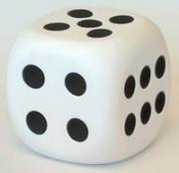
spel ________________________
vriend ________________________
kerk ________________________
dans ________________________
pion ________________________
steen ________________________
dobbelsteen ________________________
pannenkoek ________________________
bloem ________________________
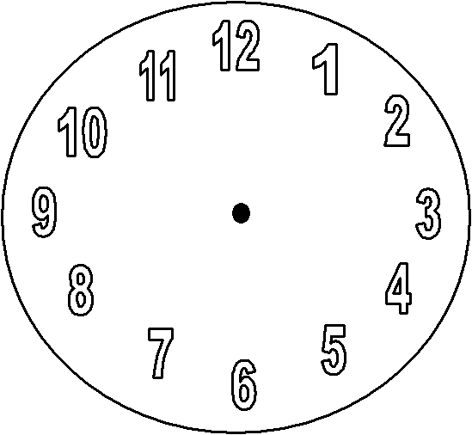
klok ________________________
tunnel ________________________

2. Vul in :

__________________ - bekertje
blad - ______________________

steen - ______________________
__________________ - boterhammetje
snoep - ______________________
banaan - ______________________
__________________ - spelletje
__________________ - papiertje
__________________ - pannetje
glas - ______________________
boom - ______________________
__________________ - sleutelhangertje
__________________ - boekje

